HACETTEPE UNIVERSITY
Department of Computer Engineering

Fuzzy Modelling
Laboratory

Furkan Simsekli
5th Semester
Turkey

Academic Year 2023/2024

Exercise 5

Write a script to calculate the algebraic product and Łukasiewicz product of fuzzy sets A, B and C, which are described using Gauss membership functions:

C1 – red Z1 – continous line
C2 – magenta Z2 – continous line
C3 – green Z3 – continous line, line character ,,o”
C4 – blue Z4 – continous line, line character ,,x”
C5 – cyan Z5 – continous line, line character ,,+”

DS = 0.15 R = [0, 10]

Draw the membership functions μ_{A}(x), μ_{B}(x), μ_{C}(x), μ_{D}(x) and μ_{E}(x) on one graph in the range of R. Use the following colours μ_{A}(x) – C1, μ_{B}(x) – C2, μ_{C}(x) – C3, μ_{D}(x) – C4, μ_{E}(x) – C5, and continuous lines for each function and line characters Z1, Z2, Z3, Z4, Z5.

Sign the membership functions in the following way: μ_{A}(x) – MFA, μ_{B}(x) – MFB, μ_{C}(x) – MFC, μ_{D}(x) – MFD, μ_{E}(x) – MFE. Use a DS discretization step.

Write the equations describing the height and the power of a fuzzy set. Determine the height of the fuzzy sets: height(D), height(E) and the power of the fuzzy sets: card(D), card(E).
Solution

% algebraic product and Łukasiewicz product
x=[0:0.15:10]
ya=exp(-(((x-5)/2).^2))
yb=exp(-(((x-6)/2).^2))
yc=exp(-(((x-7)/2).^2))
yd=ya.*yb.*yc
ye_ab=max(0,ya+yb-1)
ye_abc=max(0,ye_ab+yc-1)

% plot the curves
plot(x,ya,'r',x,yb,'m',x,yc,'g-o',x,yd,'b-*',
x,ye_abc,'c-+')
grid on
legend('MFA','MFB','MFC','MFD','MFE')

% axis, line width, font size
set(gca,'fontsize',16)

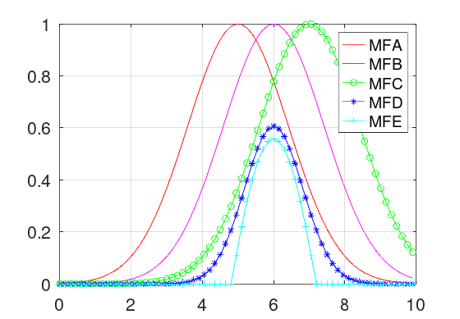
Figure 4.1: The membership functions MFA, MFB, MFC and the algebraic product MFD and the Łukasiewicz product MFD.

% calculate height
hD=max(yd)-min(yd)
hE=max(ye_abc)-min(ye_abc)

height(D) = 0.6065
height(E) = 0.5576

% calculate cardinal
cardD=sum(yd)
cardE=sum(ye_abc)

card(D) = 8.2757
card(E) = 5.7231

